Lab5 Part 1: Programming

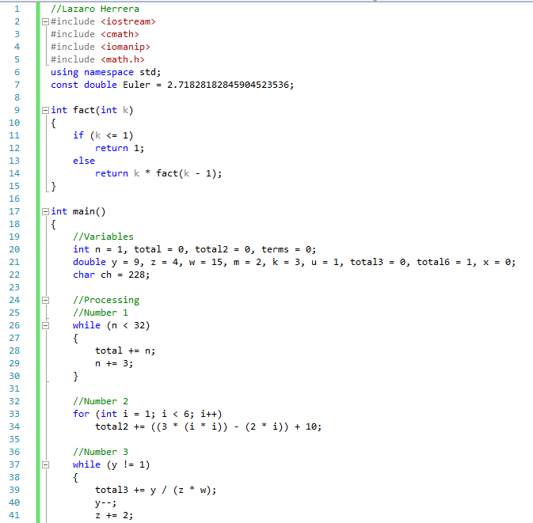

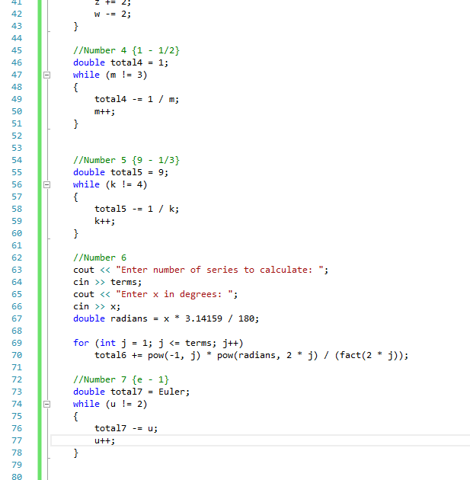

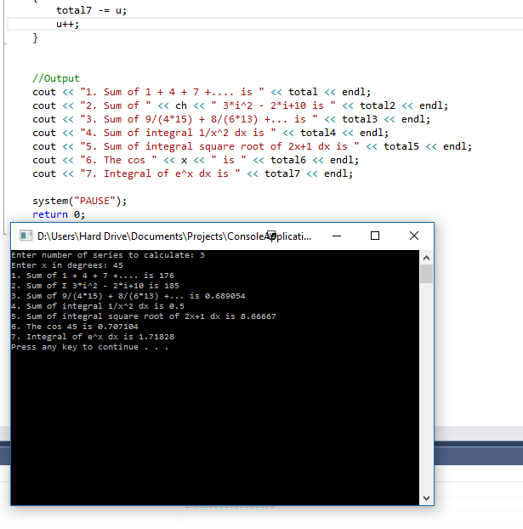

Lab5 Part 2: Programming output

1. 01234

2. Enter two integers in the range 1-20: 3 4  
 @@@  
 @@@  
 @@@  
 @@@

3. The value of x is: 11

Lab5 Part 3: Correct the error

1. Initializations should be declared outside loop  
int product = 1;

for (int i = 1; i < 5; i++)

{

product \*= i;

}

2. In the for loop, the argument should be less than or equal to 10.  
 In the cout, you need to multiply i times 2 and add 1.  
for (int i = 1; i <= 10; i++)

{

cout << i << "2 + 1 = " << i \* 2 + 1 << endl;

}